The "CROSS-INTER-MULTI-TRANS-" disciplinarit(ies) of
English Studies

5th ASSE International Conference
on British and American Studies

Organized in collaboration with the
University of Vlora “Ismail Qemali”, Vlora, Albania

6-8 June 2019, Vlora, Albania

Conference Programme

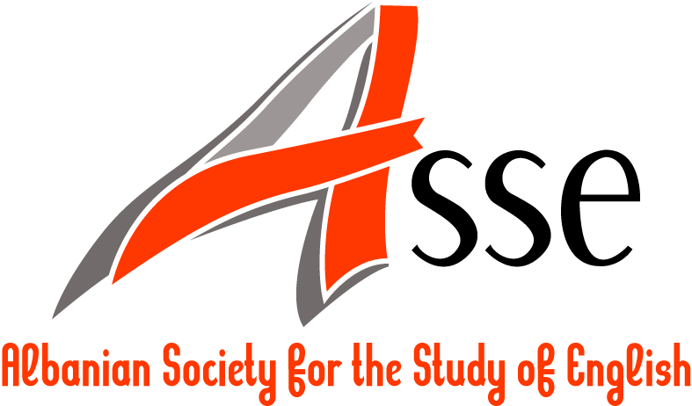

Thursday, 6 June 2019

08:30-10:00 | Registration (Faculty of Humanities)
10:00-10:30 | Welcome address
10:30-11:30 | Plenary session –Room, Faculty of Humanities
Room  B 205, Faculty of Humanities | Chair: Armela Panajoti, University of Vlora “Ismail Qemali,” Albania  Dr. György Kalmár, University of Debrecen, Hungary  Practicing the Humanities at Times of Crisis
11:30-12:00 | Coffee break
12:00-13:10 | Parallel sessions
Room  B 302, Faculty of Humanities | Translation Studies  Chair: Ilda Kanani, University of Vlora “Ismail Qemali”, Albania
Room  B 302, Faculty of Humanities | Character (re)design from source to target multimodal text. The Chicano gangster stereotype as a case study.  Dora Renna, University of Verona, Italy  Rhetorical criticism as a method for analysing bilingual local publications  Agnieszka Szurek, University of Warsaw, Poland  That wasn’t what I meant… (Interpreting obscured speech)  Ilda Kanani, University of Vlora “Ismail Qemali”, Albania
Room  B 408, Faculty of Humanities | Linguistics  Chair: Eva Sicherl, University of Ljubljana, Slovenia
Room  B 408, Faculty of Humanities | Lexical blending as a result of English influence on word-formational processes in Slovene  Eva Sicherl, University of Ljubljana, Slovenia  On the plupluperfect  Sabina Nadina Cehan, “Alexandru Ioan Cuza” University of Iaşi, Romania  Passives in English Legal Documents  Jumanca Romanita, West University of Timisoara, Romania
13:10-15:00 | Reception at Restaurant “Studenti”
15:00-16:10 | Parallel sessions
Room  B 302, Faculty of Humanities | Teaching Methods  Chair: Anca Cehan, "Alexandru Ioan Cuza" University of Iasi, Romania
Room  B 302, Faculty of Humanities | Towards Innovative Teaching Methods: Promoting Teaching 2030  Irina Petrovska, UKLO – Ohrid, North Macedonia  The post-method condition  Anca Cehan, "Alexandru Ioan Cuza" University of Iasi, Romania  Modern technologies – an ımpost or a challenge for teachers?  Žana Knežević, University “Mediterranean”, Montenegro  Extensive Reading and its Importance in Language Classroom  Veneranda Hajrulla, University of Vlora “Ismail Qemali”, Albania  Marsela Harizaj, University College “Logos”, Albania
Room  B 408, Faculty of Humanities | Discourse Analysis/ Pragmatics  Chair: Luminita Frentiu, West University of Timisoara, Romania
Room  B 408, Faculty of Humanities | Social advertising as a mechanism for managing public opinion  Tatsiana Eromeitchik, Minsk State Linguistic University, Belarus  Joke Patterns and Structures  Luminita Frentiu, West University of Timisoara, Romania  Hedging political stance in presidential debates  Bledar Toska, University of Vlora “Ismail Qemali”, Albania
16:10-16:40 | Coffee break
16:40-17:50 | Parallel sessions
Room  B 408, Faculty of Humanities | American literature/Literary studies/Film studies  Chair: Eszter Ureczky, University of Debrecen, Hungary
Room  B 408, Faculty of Humanities | The Fugitive Kind (1959): A Film Portrayal of Tennessee Williams’s South  Vesna Tripković-Samardžić, University “Mediterranean”, Montenegro  The Phenomenology of “Ugliness”: Facial Disfigurement and Female Embodiment in Autobiography of a Face by Lucy Grealy  Eszter Ureczky, University of Debrecen, Hungary  The politics of fictional literature: a cross-disciplinary approach  Elonora Hodaj, University of Vlora “Ismail Qemali”, Albania  “Beavis and Butt-head”: Comic and Derogatory Portrayal of Arabs in True Lies  Abu Shahid Abdullah, University of Asia Pacific, Dhaka, Bangladesh

Friday, 9 June 2017

10:00-11:00 | Plenary session - Conference Room (ground floor)
Room  B 205, Faculty of Humanities | Chair: Bledar Toska, University of Vlora “Ismail Qemali”, Albania  Dr. Cristina Dimulescu, Transilvania University of Braşov, Romania  The mechanism of implicature and inference as influenced by primary stimuli
11:00-11:30 | Coffee break
11:30-12:40 | Parallel sessions
Room  B 302, Faculty of Humanities | ELT/ Applied Linguistics  Chair: Artur Jaupaj, Canadian Institute of Technology, Tirana, Albania
Room  B 302, Faculty of Humanities | The importance of idioms acquisition in English language learning and teaching to Albanian EFL students - A guideline of strategies and techniques  Olsa Xhina, ‘Aleksander Moisiu’ University of Durres, Albania  English as a Lingua Franca: The case of William Shakespeare?  Thomas Christiansen, Università del Salento  Tips for Using Cooperative Learning Groups effectively in the EFL Classroom  Veneranda Hajrulla, University of Vlora “Ismail Qemali”, Albania  Marsela Harizaj, University College “Logos”, Albania  Group Names in Ethnic Slurs  Ileana Silvia Ciornei, University of Pitesti, Romania
12:40-14:30 | Lunch break
14:30-15:40 | Parallel sessions
Room  B 302, Faculty of Humanities | British and Commonwealth literature  Chair: Andreea Şerban, West University of Timişoara, Romania
Room  B 302, Faculty of Humanities | Frankenstein’s Intellectual Labyrinth: Folds in the House of Knowledge  Lubomir Terziev, American University in Bulgaria  Mocking Depiction of Corrupt Politicians: Magical Realism as a Means of Political Satire in Ngugi Wa Thiango’s Wizard of the Crow  Abu Shahid Abdullah, University of Asia Pacific, Dhaka, Bangladesh  “The secrets of my prison house” (Hamlet, I, 5): Refashioning Prisons and Imprisonment in Shakespeare’s Hamlet – Manga-Style  Andreea Şerban, West University of Timişoara, Romania
Room  B 408, Faculty of Humanities | Intercultural Communication/Semiotics  Chair: Dorjana Klosi, University of Vlora "Ismail Qemali", Albania
Room  B 408, Faculty of Humanities | Intercultural linguistic competence for intercultural intelligence  Dorjana Klosi, University of Vlora "Ismail Qemali", Albania  Globalization and Culture: An Overview of Specific Aspects of This Interaction  Irena Skendo, University of Vlora "Ismail Qemali", Albania  The semiotics of blogging: Branding Albania through social media in English  Armela Panajoti, University of Vlora “Ismail Qemali”, Albania  Tackling Violence against Children in a Cross-cultural Setting  Artur Jaupaj, Canadian Institute of Technology  Besnik Kadesha, Save the Children
15:40-16:10 |  | Coffee break
16:10-17:00 |  | Parallel sessions
Room  B 302, Faculty of Humanities | Literary Studies  Chair: Elonora Hodaj, University of Vlora “Ismail Qemali”, Albania
Room  B 302, Faculty of Humanities | A Narrative of Cosmopolitanism: An Analysis of Ismail Kadare’s A Girl in Exile in the Light of Kwame A. Appiah’s Theory of Rooted Cosmopolitanism  Edona Llukacaj, Independent scholar  Bodies on Death Row Perform their Way from the American to the European Stage  Penny Koutsi, Aristotle University of Thessaloniki, Greece  The Talk of the Cities: The Children of Pallas Athena  Vassil Anastassov, Independent Scholar  Two Way Street: Writers from Ex-Yugoslavia in the Context of Literature and Culture of the English Language  Muharem Bazdulj, University of Belgrade, Serbia
Room  B 408, Faculty of Humanities | Cultural Studies/Linguistics  Chair: Mihaela Cozma, West University of Timisoara, Romania
Room  B 408, Faculty of Humanities | Metaphorizing the EU Membership: A Study on the Romanian Young People’s Perceptions of the European Identity  Mihaela Cozma, West University of Timisoara, Romania  Metaphorical Expressions in Albanian and Serbian Ancient Law Collections  Thomas Christiansen, Università del Salento  Monica Genesin, Università del Salento  Joachim Matzinger, Österreiche Akademie der Wissenschaften
20: 00 | Conference dinner at “Pavaresia” Restaurant

Saturday, 8 June 2019

10:00-10:30 | Conference conclusions
10:30 - | Excursion to Zvernec

