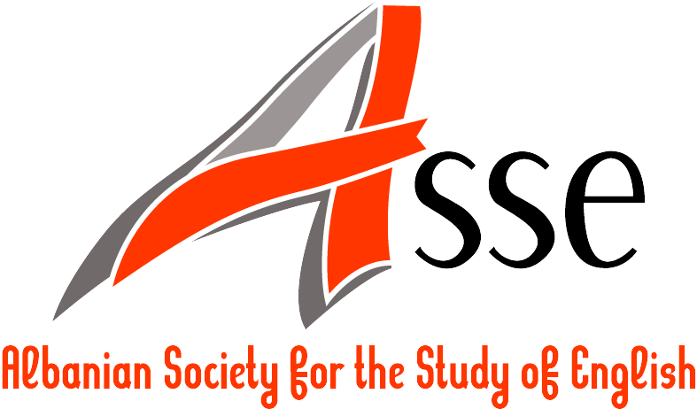

Albanian Society for the Study of English (ASSE)
http://www.assenglish.org
nation@assenglish.org, asse@assenglish.org

Registration Form

The “CROSS-INTER-MULTI-TRANS-“ disciplinarit(ies)
of English Studies

FIFTH ASSE INTERNATIONAL CONFERENCE ON BRITISH AND AMERICAN STUDIES

6-8 June 2019, Vlora, Albania

Organized in collaboration with the University of Vlora “Ismail Qemali”, Albania

Please complete the registration form and return it by e-mail by 5 May 2019 to the following e-mail address: asse2019@assenglish.org.

- Participant’s Information

Family name:
First name(s):
Title:
Affiliation:
Address:
E-mail address:
Phone number(s):

- Conference Information

Are you presenting a paper? | YES  NO   (If YES, please provide the title of your presentation):
Are you willing to chair a session? | YES  NO 
Do you have any special equipment requirements for your presentation? | YES x NO   (If YES, please specify the equipment):  Laptop with projector
How did you learn about this conference? (We would appreciate it very much if you could provide us with this information.) | Conference Alerts   Linguist List   Papers Invited   ESSE website   All Conferences   H-Net   E-mail   Other 

- Conference Fee* (Please indicate by ticking the appropriate box)

Please note that scholars may send up to two abstracts for consideration. Also, co-authors are requested to pay full conference fee.

Early registration regular (80 euros) | 
Early registration ASSE Members (60 euros) | 
Late registration regular (100 euros) | 
Late registration ASSE Members (80 euros) | 

Early registration fee is to be paid by 25 April 2019
Late registration fee is to be paid by 5 May 2019

* The conference fee covers:
- the conference folder and badge
- refreshments during breaks
- conference reception
- conference dinner
- certificate of attendance
- excursion
- editorial expenses
If you have any queries, please do not hesitate to contact the conference organizers at asse2019@assenglish.org.

